The Role of COVID-19 on Firms’ Absorptive capacity, strategic orientations, and big data capability

Institution
Course
Instructor
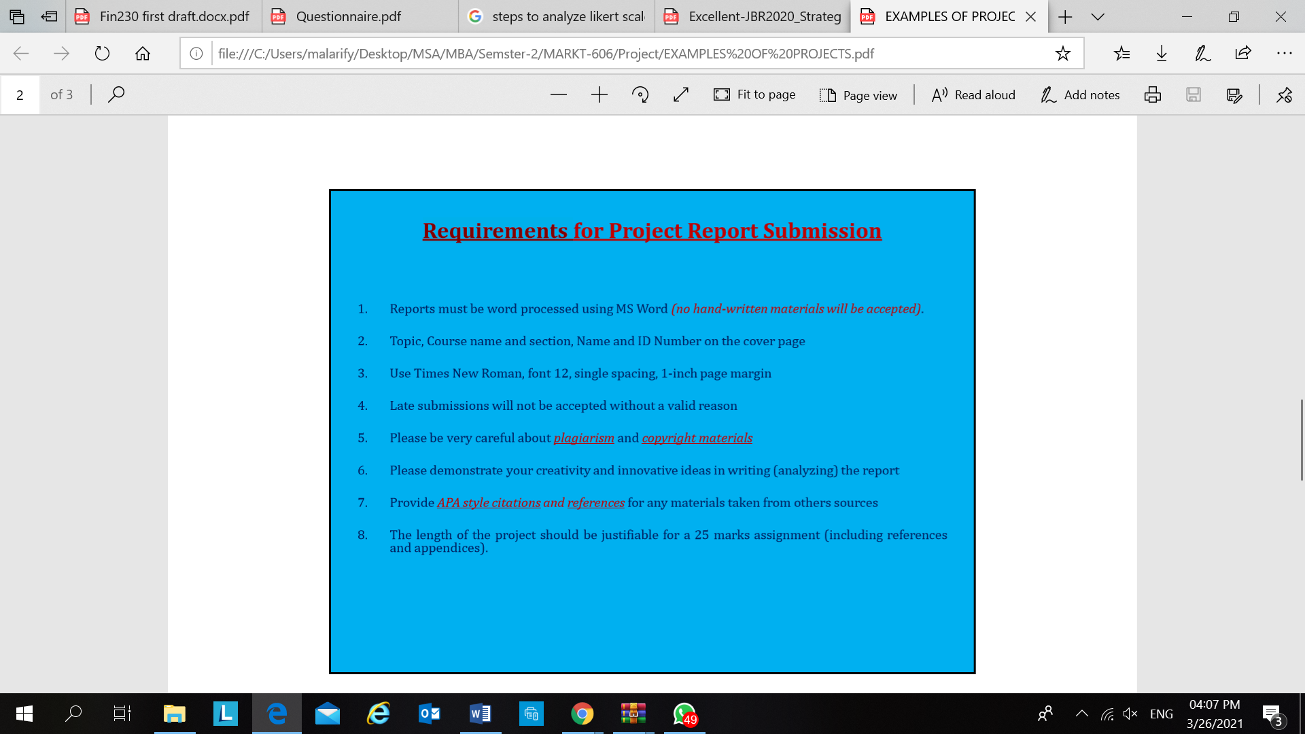
Date

8. Including references and appendixes

Research with at least 5000 ward with ppt 20 slides
Abstract
Key words:
- Introduction
1.1 Research question
1.2 Research objectives
- Theoretical Background and Hypothesis Development
- Absorptive Capacity:
- Big Data Capability (BDC):
- Customer Orientation:
- Technological Orientation (TO):
- Entrepreneurial Orientation (CUSO):
- Developmental Culture (DC):
- 2.1. Variable 1 definition (……………. )
- 2.2. Variable 2 definition (..............)
- 2.3. Variable 3 definition (………………)
- 2.4. Variable 4 definition (………………)
- 2.5. Variable …etc. definition (………………)
- 2.6. Hypothesis development
Figure1: conceptual model

H1. : ………….etc.
H2. : ……..etc.
H3. :……..etc…

- Research Methodology
- 3.1. Data collections and sample

- 3.2. Measures

Table 1: Summary of measurement items
- 3.3. Data analysis
Two types of analysis to be used:
1. Descriptive Analysis:
All the 8 Demographic Profiles questions (Mean, Median, Mode, SD, Frequency, Pie chart, Histogram, Bar Chart, Line chart, trend/pattern analysis)
2. Regression Analysis:
a. Model Summary
b. ANOVA Table
c. Coefficients
Structure Equation Model
Figure 2: Structural Equation Model Results
- Results
- 4.1. The assessment of the measurement model

Table 2: Measurement model – 1
Table 3: Measurement model – 2
Table 4: Measurement model – 3

- 4.2. Testing of the structural model
Table 5: Structural Model

- Discussion, conclusion, limitations and future research
- Discussion of results
- Theoretical contributions
- Managerial contributions
- Limitations and future work
- Conclusion
References 15 at least (APA STYLE)
Appendix
Need to analyze Demographic data then add the Demographic table at the end of report

